For the first four (4) questions, refer to the diagram below.
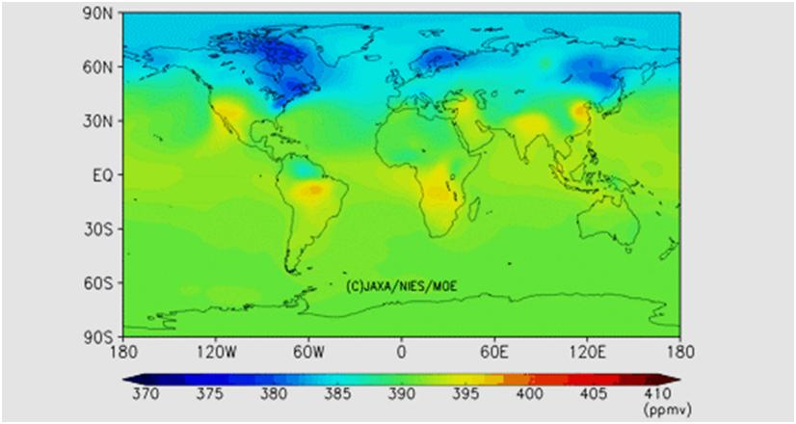
Figure 1: Level 4B data product. A sample map extracted from global three-dimensional CO₂ distribution, at an altitude of approx. 800 m (0.925 level on a hybrid sigma-pressure coordinate), August 2012. http://www.gosat.nies.go.jp/en/about_5_products.html
- ______ How can it be inferred that the above map was produced during the northern summer?
  - The cloud cover is greater in the northern hemisphere because of increased convection.
  - The levels of the detected gas are low because growing vegetation absorbs it.
  - Less energy is used during warm months, so less of the gas is produced.
  - Wind speeds are greater in the northern hemisphere due to increased solar forcing.
  - The spectral differential shows that the temperature is higher in the northern hemisphere.
- ______ A satellite obtained the data in the map above. Which property of the target gas allowed the satellite to obtain these data?

  - Extinction
  - Radiance
  - Reflectance
  - Transmittance
  - Temperature

- ______ Which is the most likely wavelength used in order to detect the gas in the above diagram?

  - 55 μm
  - 18 μm
  - 11 μm
  - 3 μm
  - 1 μm

- ______ Which satellite would be most appropriate for collecting the data observed in the above image?

  - PARASOL
  - AURA
  - CLOUD-SAT
  - AQUA
  - OCO
  - CALIPSO

For the next three (3) questions, refer to the diagram below.
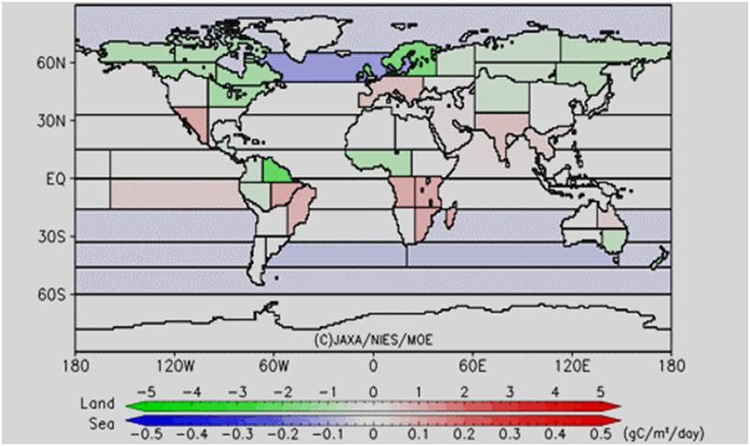
Figure 2: Level 4A data product. A sample map of regional CO₂ flux estimates, August 2012. http://www.gosat.nies.go.jp/en/about_5_products.html
- ______ Which of the following areas shows a significant negative flux in carbon dioxide emissions in August, 2012?

  - Northern Europe
  - South Africa
  - Antarctica
  - Australia
  - Northeastern Russia

- ______ Why is the scale for oceanic carbon dioxide flux different than the flux for dry land?
  - Dry land flux occurs on a smaller scale, due to more industrial and vegetation influences.
  - Solar forcing causes oceanic flux to occur on a greater scale.
  - Spectral resolution is decreased due to the method of passive remote sensing.
  - Greater temperature shifts over land disrupt detection of the gas.
  - Oceanic flux occurs on a smaller scale, due to greater absorption and retention of CO₂.
- ______ What strategy was used to collect the data necessary to compile the above image?

  - Cloud aerosol Lidar
  - Change detection
  - Occultation measurements
  - Optical spectral analysis
  - Gas chromatography
  - Bismarck analysis

For the next five (5) questions, refer to the diagram below.
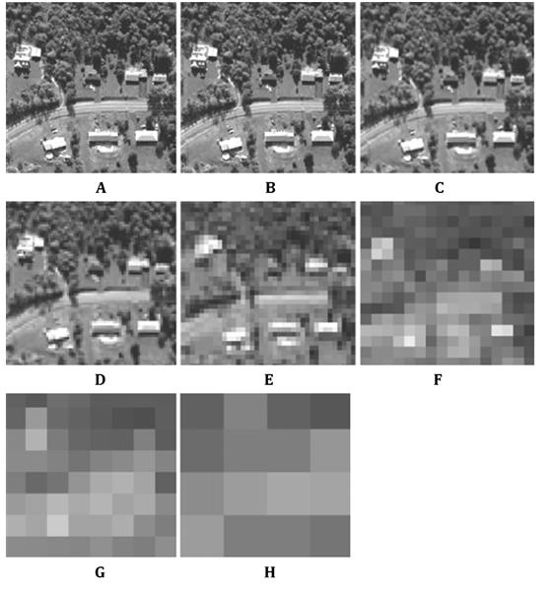
- ______ Which of the following images exhibits the highest spectral resolution?

  - A
  - C
  - E
  - G
  - None of the above

- ______ Which of the following images exhibits the greatest spacial resolution?

  - C
  - D
  - E
  - F
  - None of the above

- ______ Which type of remote sensing was used to produce the above images?

  - Atmospheric sensing
  - Passive sensing
  - Active sensing
  - Wavelength sensing

- ______ Suppose images A and B were taken 14 days apart. Images D and E were taken 5 days apart. Which pair of images exhibits the greatest temporal resolution?

  - A and B
  - A and D
  - A and E
  - D and E
  - D and B
  - B and E

- ______ Consider image B. Which of the following best estimates the pixel size?

  - 10 m x 10 m
  - 0.1 m x 0.1 m
  - 1 m x 1 m
  - 50 m x 50 m
  - 5 m x 5 m
  - 100 m x 100 m

For the next three (3) questions, refer to the diagram below.
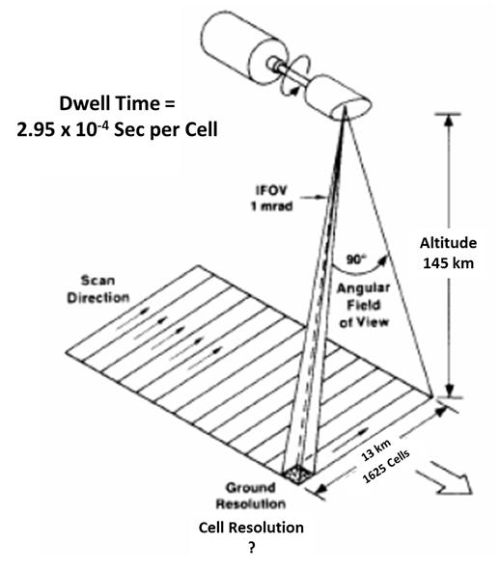
- ______ For the satellite shown above, calculate the cell (pixel) resolution.
  - 5 m x 5 m
  - 8 m x 8 m
  - 10 m x 10 m
  - 14 m x 14 m
  - 30 m x 30 m
- ______ Calculate the scan rate for the satellite above.
  - 5.2 x 10⁻² seconds per cell
  - 6.2 x 10⁻¹ seconds per cell
  - 3.7 x 10⁻⁵ seconds per cell
  - 4.8 x 10⁻² seconds per cell
  - 2.3 x 10⁻⁵ seconds per cell
- ______ Which type of scanning system is shown in this diagram?
  - Active scanner
  - Cross-track scanner
  - Mirror-facilitated scanner
  - Push broom scanner
  - Passive scanner
  - Along-track scanner

For the following three (3) questions, refer to the diagram below.
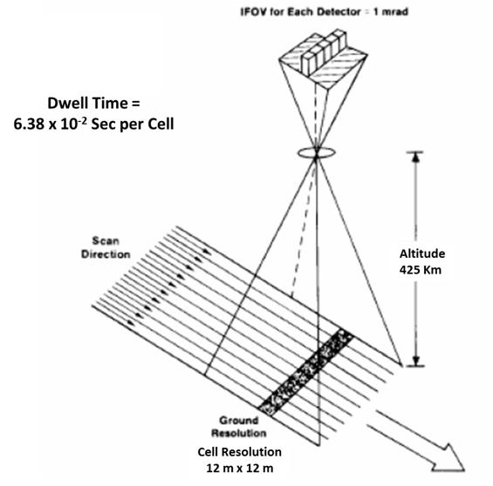
- ______ Calculate this satellite’s orbital velocity.
  - 5.1x10³ meters per second
  - 27 meters per second
  - 241 meters per second
  - 188 meters per second
  - 35 meters per second
- ______ Which type of scanning system is shown in this diagram?
  - Along-track scanner
  - Active scanner
  - Cross-track scanner
  - Whisk broom scanner
  - Passive scanner
  - Mirror-facilitated scanner
- ______ Consider the altitude above. What is the term for the pyramidal shape between the surface and the satellite?
  - Focal plane
  - Field stop
  - Instantaneous field of view
  - Dwell time
  - Angular field of view

For the next three (3) questions, refer to the diagram below.
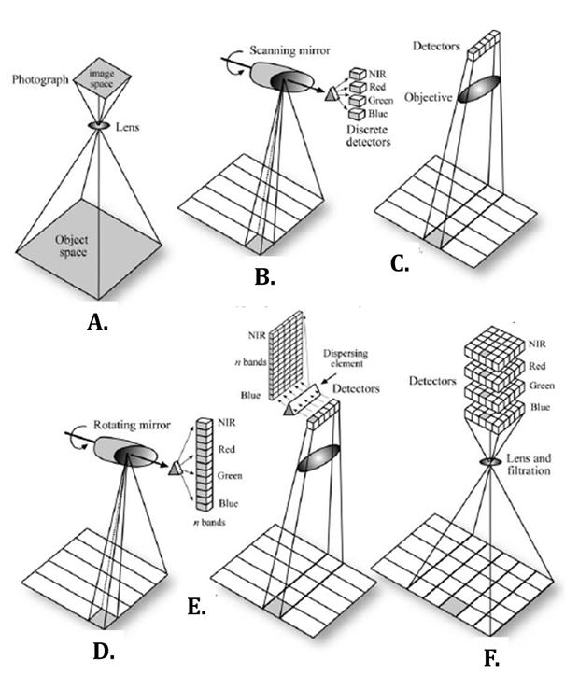
- ______ Which of the satellites shown above uses what would be considered a hyperspectral array?

  - A
  - B
  - C
  - D
  - E
  - F
  - None of the above

- ______ Which of the satellites shown above exhibits a digital frame camera with area arrays?

  - A
  - B
  - C
  - D
  - E
  - F
  - None of the above

- ________________________ Which of the above satellites could be employed for passive sensing? Mark all that apply.

  - A
  - B
  - C
  - D
  - E
  - F
  - None of the above

For the next five (5) questions, refer to the diagram below.
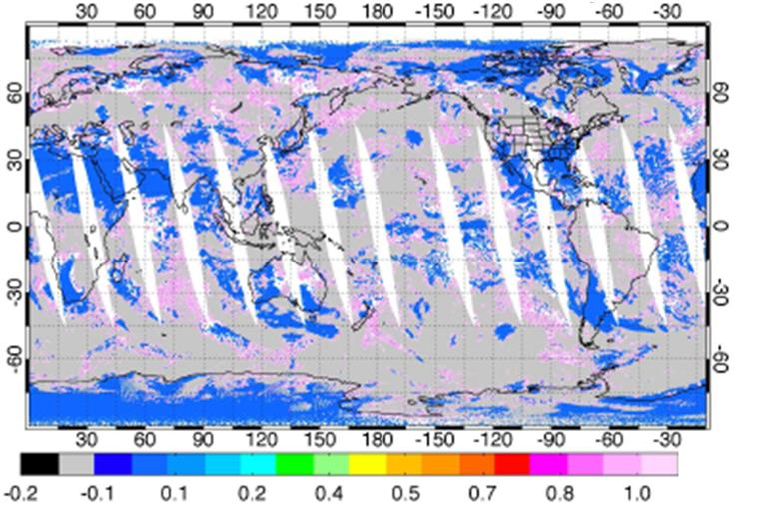
Figure 3: Cloud ratio from MODIS cloud mask. Image captured by AIRS instrument aboard MODIS satellite on March 4, 2006, daytime.
- ______ Which regions in the diagram above indicate a cloudy area?

  - Blue
  - Grey
  - Pink
  - White
  - None of them; this map does not show clouds.

- ______ The image above was produced by a single satellite. Which of the following describes this satellite’s orbit?

  - Eccentric orbit
  - Polar orbit
  - Geostationary orbit
  - Low Earth orbit
  - Irregular orbit

- ______ What explains the fourteen white lens-shaped streaks running north to south?
  - These are areas outside of the satellite’s field of view.
  - These are areas of high cloud coverage.
  - These are areas disrupted by interference from the magnetosphere.
  - These are areas that could not be processed at ground level.
  - These are international non-surveillance areas.
- ____________ Consider the means by which the satellite detected these data. The extinction coefficient of the clouds (β_{e}) results from what two factors? Mark the two that apply!
  - The transmission spectrum wavelength
  - The absorption coefficient
  - The Rayleigh scattering coefficient
  - The transient emission coefficient
  - The scattering coefficient
- ______ A white cloud’s β_{a} is likely to be

  - ≈ 1
  - ≈ 0.5
  - ≈ 0
  - ≈ -0.5
  - ≈ -1
  - This cannot be known without more data.

For the following two (2) questions, refer to the diagram below.
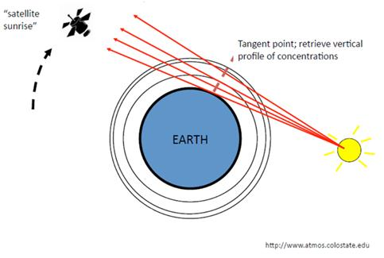
- ______ What type of remote sensing strategy is being used in the diagram shown above?

  - Sunrise measurement
  - Tangential radar
  - Infrared scanning
  - Occultation measurement
  - Eclipse measurement

- __________________ Which atmospheric qualities can be used to employ the strategy shown above? Mark all that apply.

  - Scattering
  - Absorption
  - Wavelength
  - Aerosols
  - None of the above

For the following four (4) questions, refer to the diagram below.
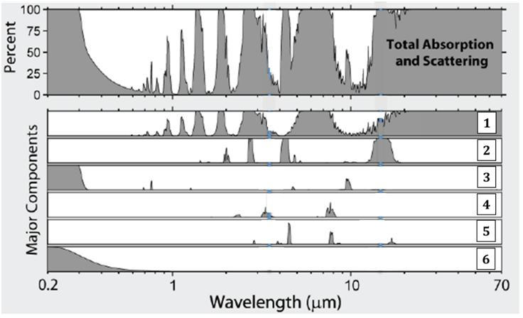
- ______ The majority of absorption and scattering is toward the longer wavelength regions of the graph, shown dominantly in row 1. Which atmospheric gas is likely to be responsible for most of these long-wavelength signatures?

  - Diatomic nitrogen
  - Ozone
  - Carbon dioxide
  - Nitrous oxide
  - Water vapor
  - Methane

- ______ There are two significant signatures toward the shorter wavelength regions of the graph. Which atmospheric gas is most likely responsible for the most significant signature at the shorter wavelengths, such as at 0.3 μm? An example dominates in row 3.

  - Diatomic nitrogen
  - Ozone
  - Carbon dioxide
  - Nitrous oxide
  - Water vapor
  - Methane

- ______ Row 4 represents a gas that shows medium strength absorbance signatures at wavelengths of about 3.5 μm and 8 μm. Which of the following is the gas responsible for these data?

  - Diatomic nitrogen
  - Ozone
  - Carbon dioxide
  - Nitrous oxide
  - Water vapor
  - Methane

- ______ Consider row 6. This graph is interesting in that it shows the effect not of a gas, but of a physical property of light passing through a medium of any composition. What property is illustrated in row 6?

  - Optical lensing
  - Transmittance
  - Rayleigh scattering
  - UV absorption
  - Backfeeding

For the next four (4) questions, refer to the diagram below. The dark arrows represent beams of light.
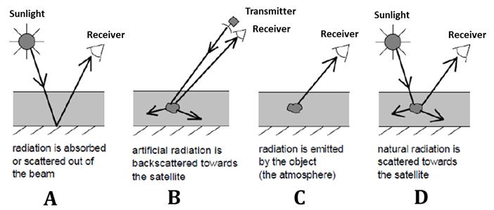
- ______ Which of the sensing systems shown is likely to employ RADAR and LIDAR scanners?

  - A
  - B
  - C
  - D
  - All of the above

- ______ Which of the strategies shown above would qualify as backscatter detection?

  - A
  - B
  - C
  - D
  - A and C

- ______ Which figure shows the results of extinction?

  - A
  - B
  - C
  - D
  - None of the above

- ______ Which strategy would be the best one to use if you were trying to observe cloud cover?

  - A
  - B
  - C
  - D
  - All would work equally well.

For the next two (2) questions, refer to the photographs below.
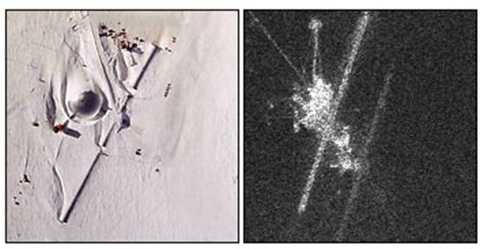
- ______ The above photographs depict Amundsen-Scott Station, a research station at the South Pole. The left photograph shows the station in natural visible light. What is shown in the right image?

  - A radar image.
  - A UV image.
  - A microwave image.
  - An infrared image.
  - A radio image.
  - A nighttime optical photograph.

- ______ What can be learned by comparing the two images?
  - A significant portion of the station’s energy is wasted as heat.
  - The station is outfitted with a sophisticated computer network.
  - The station is unlikely to be currently inhabited.
  - There appear to be structures present that are invisible to natural light detection.
  - The station is built in an area with low average temperatures.
For the next five (5) questions, refer to the diagram below.
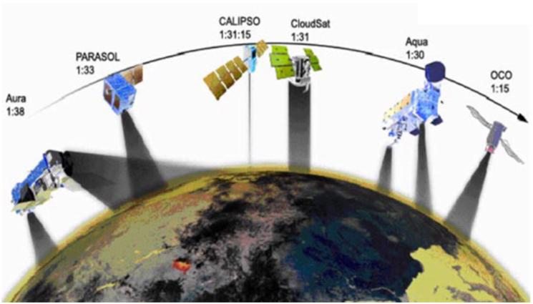
- ______ Shown here are examples of

  - Passive sensing
  - Active sensing
  - A-train satellites
  - Doppler satellites
  - T-train satellites

- ______ Which satellite(s) would be best equipped to study clouds, specifically using a cloud aerosol LIDAR? Mark all that apply.

  - PARASOL
  - AURA
  - CLOUD-SAT
  - AQUA
  - CALIPSO
  - OCO

- ______ Which satellite(s) would be outfitted with instruments to monitor the planet’s radiative budget? Mark all that apply.

  - PARASOL
  - AURA
  - CLOUD-SAT
  - AQUA
  - CALIPSO
  - OCO

- ______ These satellites follow which type of orbital path?

  - Eccentric orbit
  - Geostationary orbit
  - Low Earth orbit
  - Polar orbit
  - Irregular orbit

- __________________ Which instrument(s) can be found aboard the AURA satellite? Mark all that apply.

  - POLDER
  - Imaging Infrared Radiometer
  - HRDLS
  - CALIOP
  - Ozone Monitoring Instrument
  - Atmospheric Infrared Sounder

For the next three (3) questions, refer to the diagram below. Shown is a small portion of Brazil.
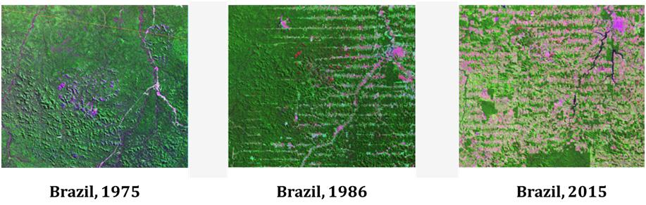
- __________________ Note all the changes that can be directly observed in the images shown in the diagram between 1975 and 2015. Mark all that apply.

  - Texture
  - Shape
  - Size
  - Color
  - Pattern

- ______ The instrument that most likely was used to observe Brazil was

  - Lidar
  - Optical photography
  - Thermal imaging
  - Radar
  - Occultation measurement

- ______ Which global process most likely explains the changes seen above?

  - Seasonal changes
  - Global climate change
  - Smog
  - Deforestation
  - Global sea level changes
  - Acid precipitation

For the next two (2) questions, refer to the diagram below.
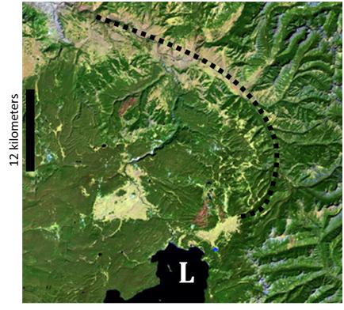
- ______ What is the approximate length of the mountain ridge indicated by the dashed line?

  - 55 kilometers
  - 45 kilometers
  - 75 kilometers
  - 30 kilometers
  - 60 kilometers
  - 35 kilometers

- ______ What is the approximate square area of the body of water indicated by the letter L?

  - 20 km²
  - 60 km²
  - 40 km²
  - 10 km²
  - 50 km²
  - 30 km²

For the next five (5) questions, refer to the diagram below. Depicted is an image of a region on the coast of Finland in July, 2014.
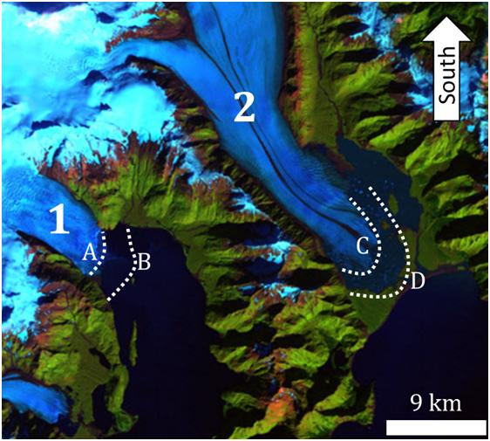
- ______ Consider the blue structures labeled 1 and 2. What is the likely identity of these structures?

  - Landslide debris
  - Alpine glaciers
  - River deltas
  - Ancient flood planes
  - Cloud formations

- ______ Consider structure 2. The dashed lines labeled C and D depict the seaward extent of this structure at different times. Which of the following statements correctly explains the relationship between the extents C and D? (Note: The dashed lines A and B show the seaward extents of structure 1 as well.)
  - Line C is the current seaward extent; line D was the former extent.
  - Line D is the current seaward extent; line C was the former extent.
  - Line C is the winter extent; line D is the summer extent.
  - Line C and line D fluctuate from month to month.
- ______ Which process most likely explains the discrepancy between dashed lines C and D?

  - Deforestation
  - Seasonal changes
  - Global climate change
  - Global sea level changes
  - Active sensing
  - Acid precipitation

- ______ Which of the following most accurately estimates the square area between lines A and B?

  - 6 km²
  - 20 km²
  - 2 km²
  - 15 km²
  - 10 km²

- ______ The most important factor in interpreting the diagram above is illustrated by comparing structures 1 and 2 with the surrounding areas depicted by green. The primary quality that distinguishes the blue structures from the green areas is

  - Tone
  - Pattern
  - Association
  - Shape
  - Texture
  - Size

- ______ Shown below is a satellite using a pulse of laser energy to observe a planet’s surface. Which instrument is being used here?
  - Electrographical analyzer
  - RADAR
  - Pulsating beam analyzer
  - LIDAR
  - Optical spectral analyzer
  - SONAR
